Chien Shiung Wu
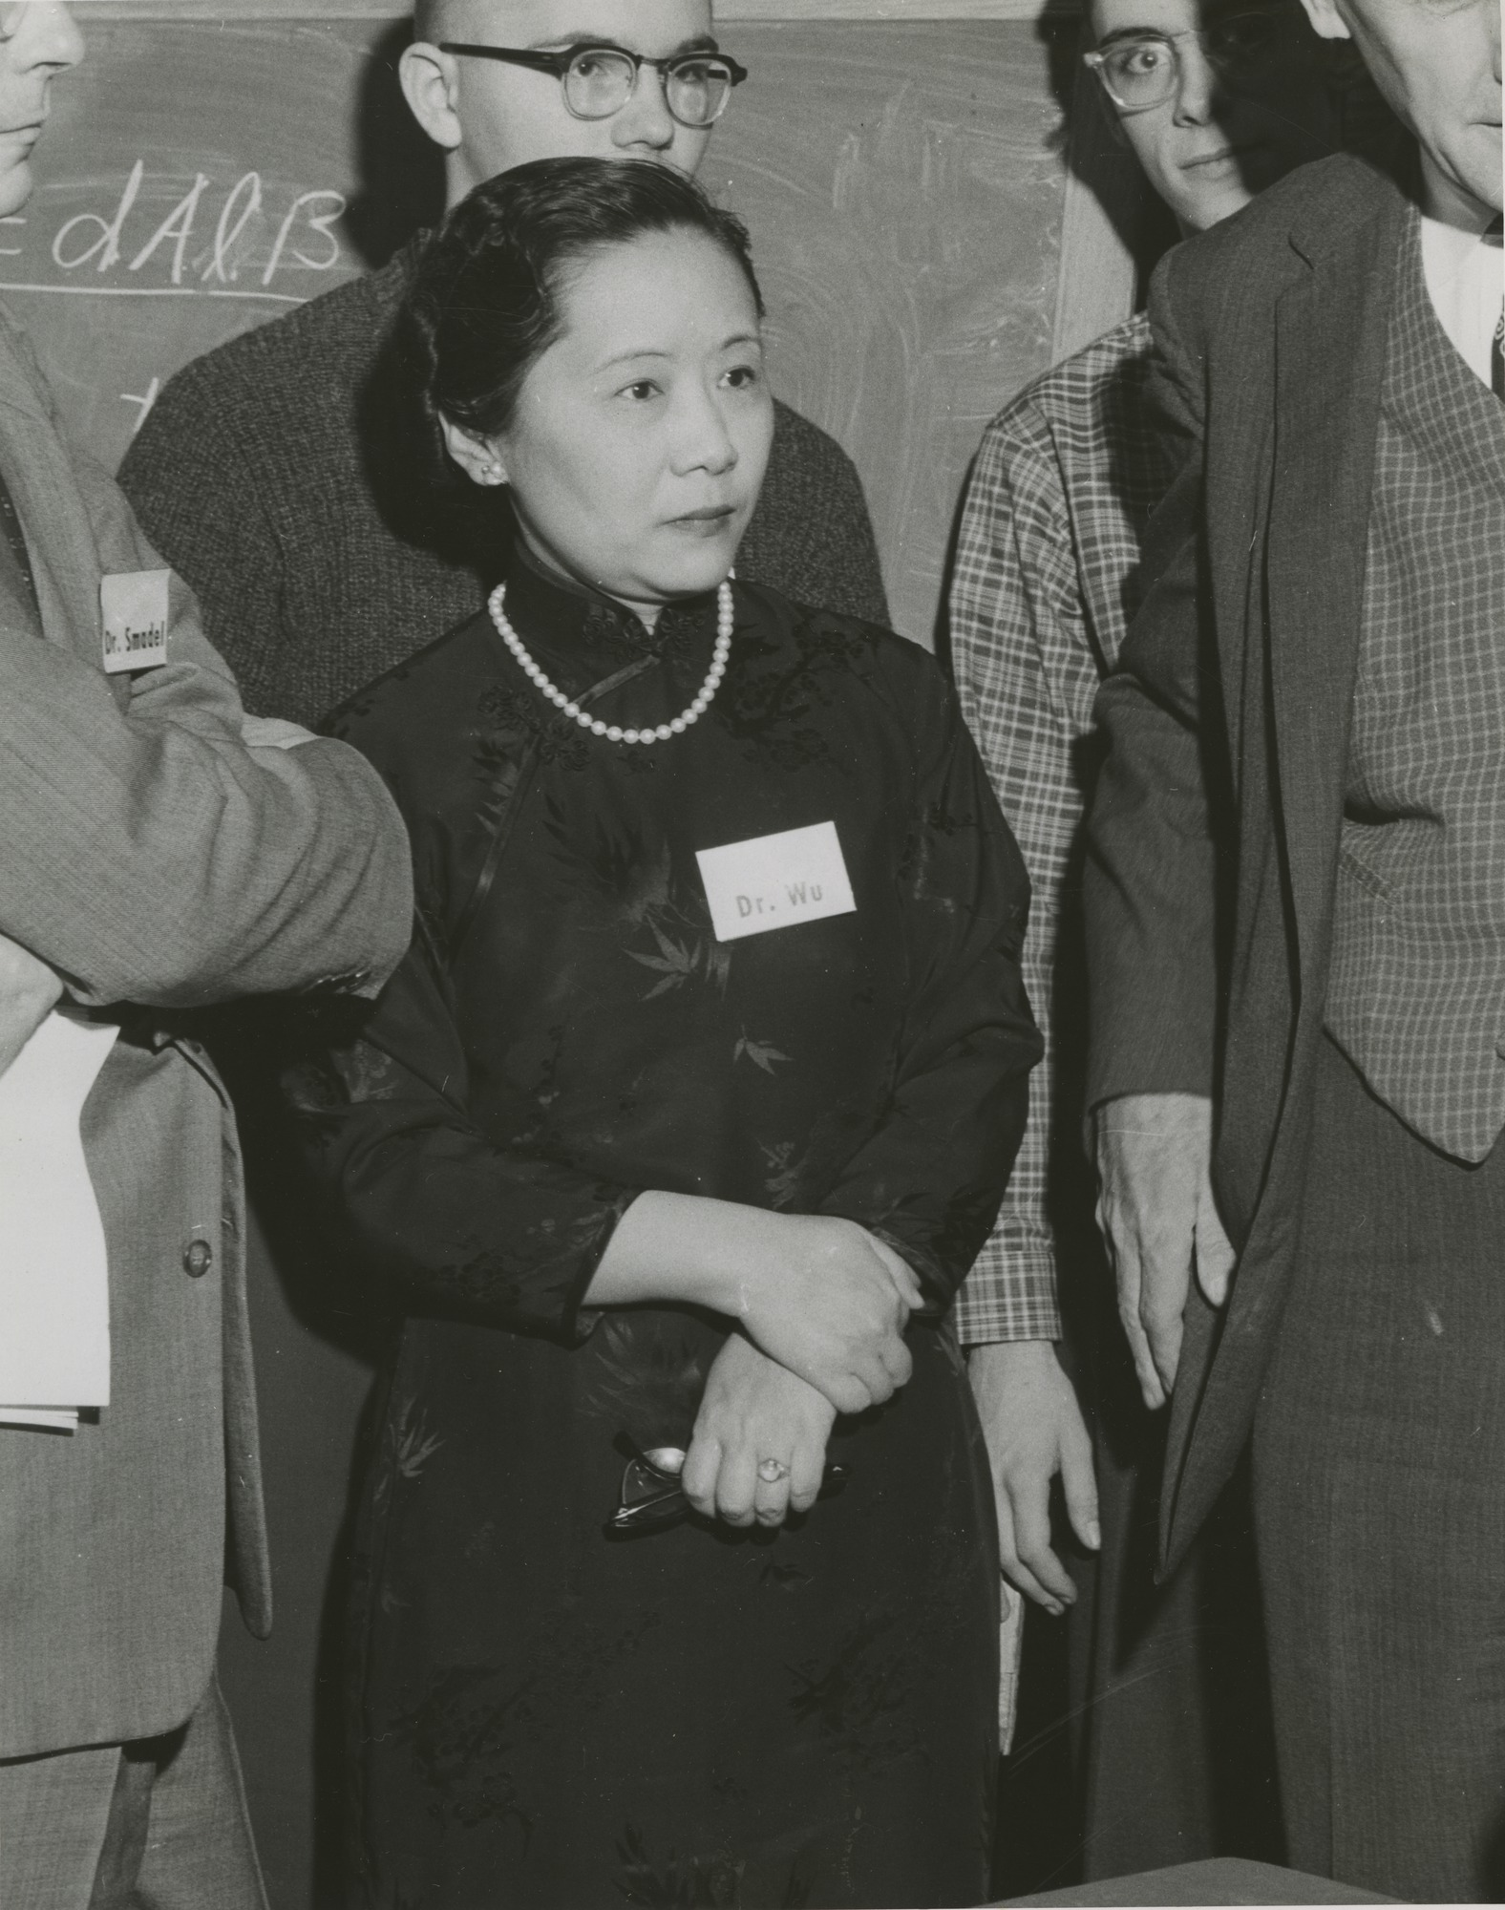
31st May 1912-16th February 1997
Chinese-American experimental physicist who made significant contributions in the field of nuclear physics

