Mathematician of the Week

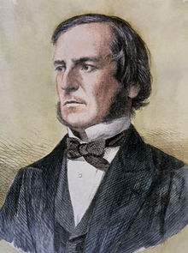

George Boole
November 2nd 1815-December 8th 1864

