Lord Ve’ehala

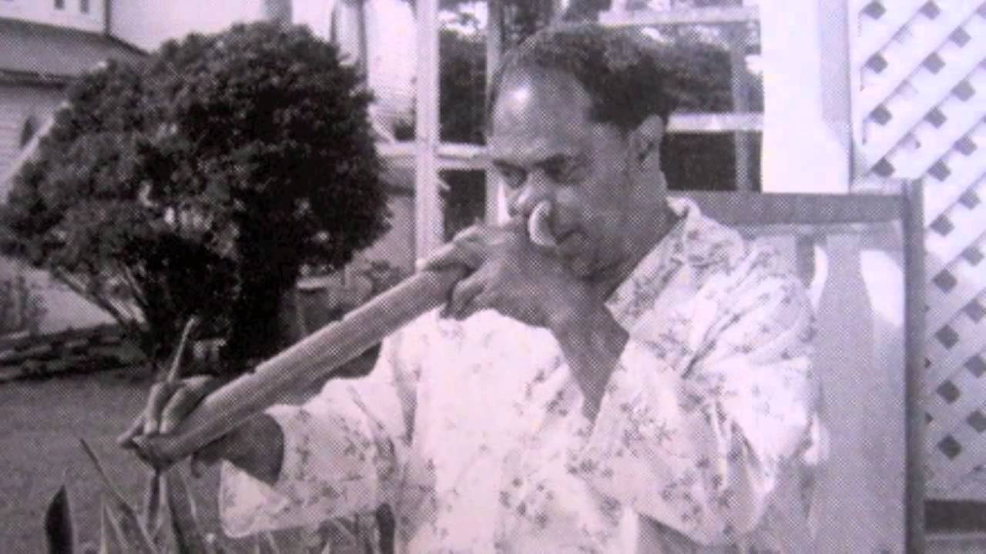

Tongan musician
1925-1986

The most famous Tongan musician, both at home and abroad, and his recordings are still traditionally the first broadcast every day by Radio Tonga.

