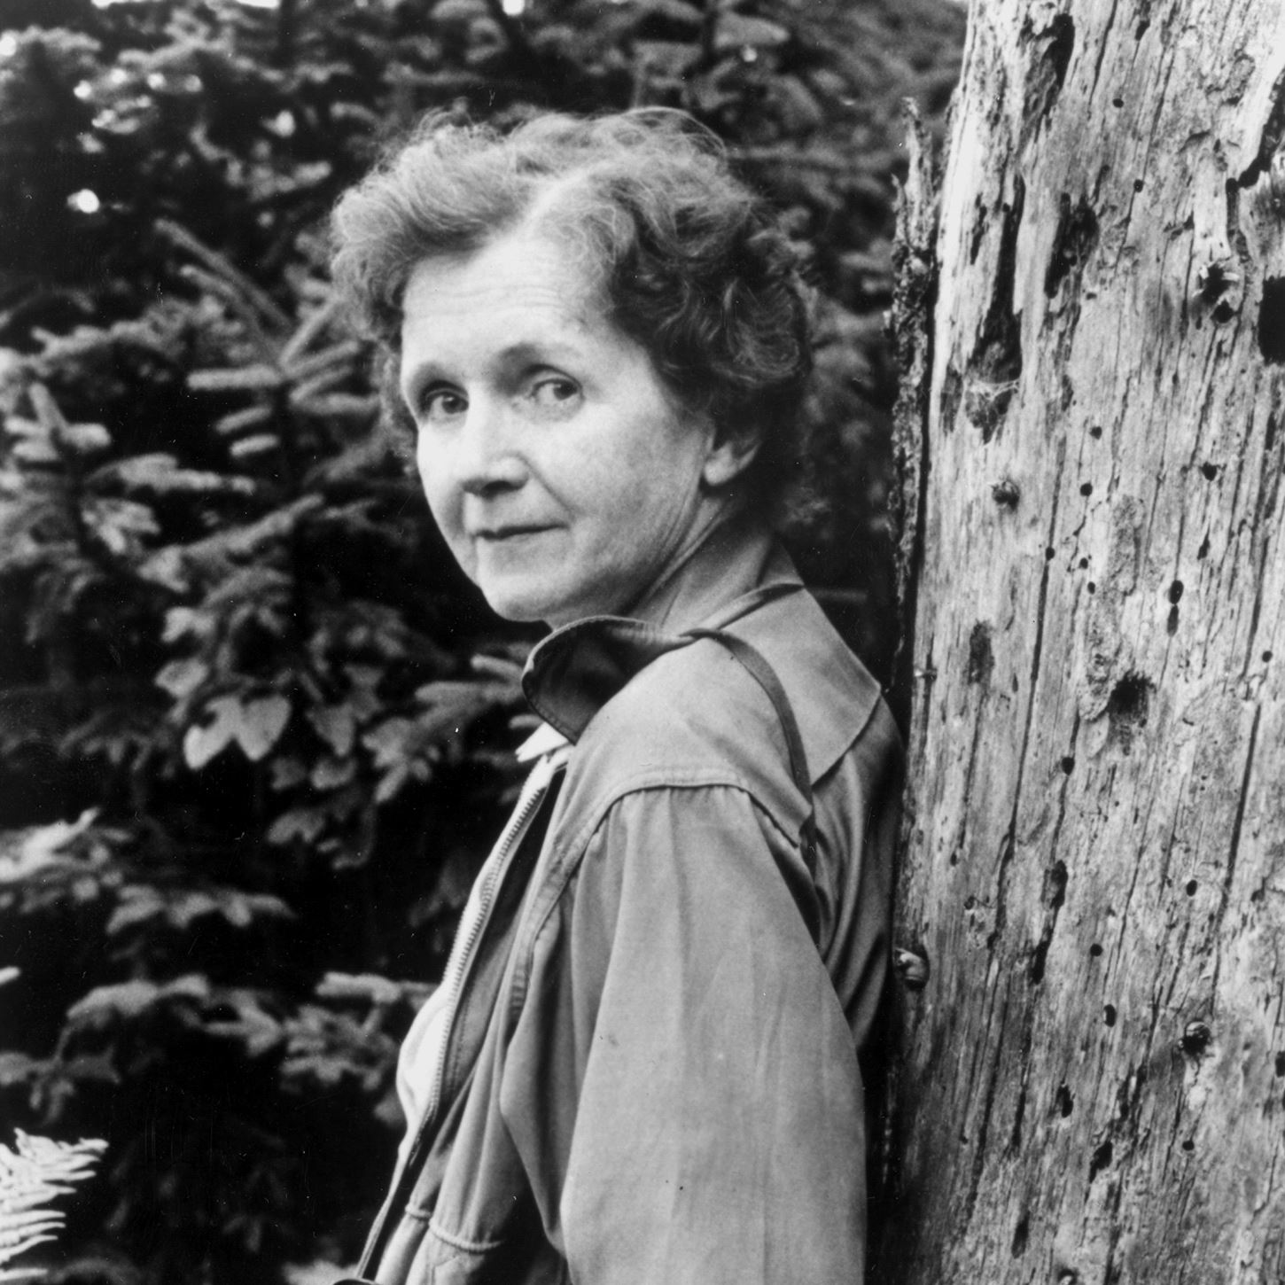

Rachel Carson
1907-1964
Rachel Louise Carson was an American marine biologist and conservationist whose book Silent Spring and other writings are credited with advancing the global environmental movement.

